# Lesson 03 – JQuery methods

# Session 2 Worksheet

# Problem 1:

Sarah wants to create an application to calculate the shipping cost for online bulk purchase of books.

**Form page (shipCostCalculator.php) – values given are example only**

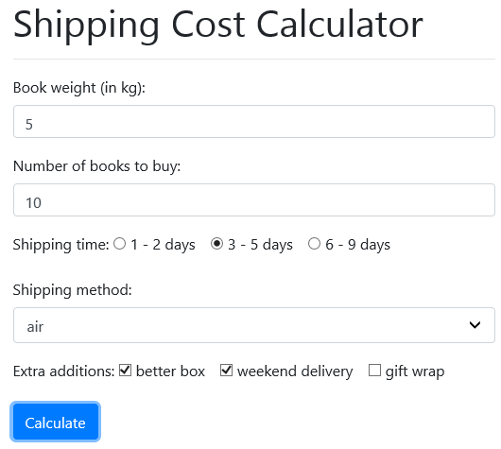

Diagram 1_1

Users can enter:

* the book weight (in kg)
* how many copies of the book to buy
* shipping time (select only one): 1-2 days, 3-5 days, 6-9 days
* shipping method (select only one): air or sea
* extra service (may select more than one): better box, weekend delivery, gift wrap

When the Calculate button is clicked, the form page will display the results in a pop-up confirmation window.

**Hint**: Use the confirm function() <https://www.w3schools.com/jsref/met_win_confirm.asp>

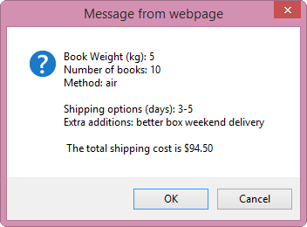

Diagram 1_2

The shipping cost is displayed by retrieving the information provided in the **form page** and use them to calculate the total shipping cost.

The shipping cost breakdown is shown below:

|  |  |  |
| --- | --- | --- |
| **category** | **type** | **cost (dollars)** |
| time (days) | 1-2 | 40 |
| 3-5 | 25 |
| 6-9 | 10 |
| Method | Sea | 40 |
| Air | 30 |
| extra service | better box | 10 |
| weekend delivery | 15 |
| gift wrap | 15 |
| total weight |  | 0.5 per kg |

If the number of books is more than 3, then a discount of 10% is applied on the total shipping cost.

If the user clicks on the “Cancel” button, the user will be brought back to the form page. However if he clicks on the “OK” button, the shipping cost information will be inserted into the “books” database table.

**TODO:** Using Netbeans, create a project called C273_L03ShipCostCalcApp. Follow the instructions in the document **Web templates with jQuery.docx** in LEO C273 “Resources” Learning Path to create an offline Bootstrap with Font Awesome and jQuery web template called shipCostCalculator.php. Create a Bootstrap form and complete the jQuery portion to process all information correctly.

**TODO:** Complete **doShipCostCalculator.php** to retrieve all the submitted form fields and insert the data into the books database table. C273_p03.sql file is provided in the problem package. You can import the database tables using PHPMyAdmin.

Recap C203’s P05 on inserting data into database using PHP

The content below is taken from C203-P05-WS-Session1.docx

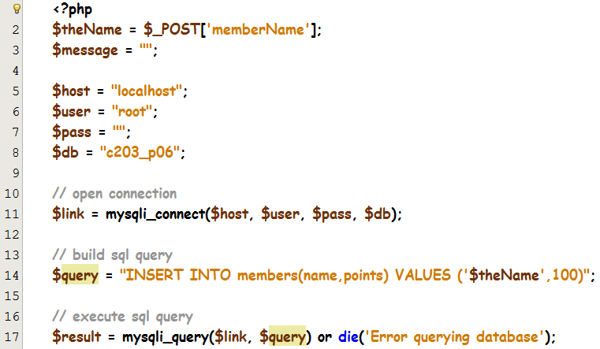

Line 2 – process the name retrieved from the form page

Line 5-8 – Set DB connection parameters $host = "localhost": MySQL server and Web server reside in the same computer

Line 14 – build the SQL query to assign 100 for the points, and save them into the database table ***members***

Line 17 – the query is executed using the connection $link created in line 11. For insert, update and delete queries, mysqli_query function will return TRUE for successful queries, FALSE on failure.

Continue typing the rest of the code below to check the status of the executed query and display the appropriate message.

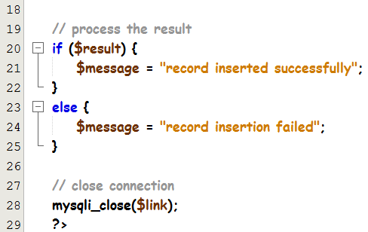

Line 28 – the connection is closed.

**Remember to print out $message within the <body> tags of the page using the echo command.**

# Challenge Yourself

Modify the jQuery portion of shipCostCalculator.php as follows:

* 1. If all extra services are selected, display the following in the pop-up window:

"You have selected all extra services"

* 1. If the number of books is more than 3 and there is at least extra service chosen, then the discount will be **15%** instead of 10%